# Data collection and User testing

## Initial Data Gathering

Date: 02/11/2022

Aim: Collect project-relevant information about how people interact with media and mental wellbeing to inform the direction and next steps of the project.

Format: Anonymous digital survey, created with Google forms.

This research aims to help build up the background of the project and identify key concepts to be further investigated throughout the project. The questions aren’t related to the product I’ll be creating, but rather, to people’s attitudes and experiences with the subjects. There will be a mix of qualitative and quantitative data points, so that I can analyse trends and identify specific areas that respondents resonate with.

Artifacts:

The survey is saved as a PDF named *InitialSurvey* in **Documentation**>**Testing**.

### Results

*DEMOGRAPHIC INFORMATION:*

## Dialogue Demo User Testing

Date: 01/03/2023

Aim: Gather user feedback about the storytelling, style, and writing of a small dialogue demo to inform the full dialogue and branching options for the main project.

Format: Anonymous digital survey, created with Google forms. Dialogue demo, created with YarnSpinner and available to play through in browser on my personal portfolio site.

This user testing aims see how effective my current approach to dialogue writing is at creating believable characters, communicating complex storylines, and encouraging expected responses from players. To ensure that all feedback is relevant to the writing itself, the dialogue demo provided is text only, with minimal user interface. The survey then asks a mixture of qualitative and quantitative questions, to provide an overall measure of the success of the demo, as well as detailed responses to gain insight into the smaller details and issues identified by users that I might not have accounted for.

Artifacts:

The survey is saved as a PDF named *DialogueDemoSurvey* in **Documentation**>**Testing**.

The demo is saved as a YARN file named *DialogueDemoYarn* in **Documentation**>**Testing**.

### Results and Analysis

Total participants: 6

Question by Question Analysis:

*Section 1: CHARACTERS*

*Q1: How would you describe the character you met? Consider attributes such as age, appearance, history, personality.*

* Old dusty grouchy lonely
* Elderly, someone who may have had a difficult past and has walls up as a result, somewhat defensive and cold but you can also tell that there is still a softer side to them despite them trying not to show any vulnerability
* Old and a little grumpy with some sort of interesting past
* Old, Single, Veteran, Introvert, Easily spooked,
* Retired pensioner living on her own, little to no visits from family or friends. Depressed, suspicious, lonely- they all present as irritability. Enjoys the company of birds & brushes but hasn't painted in a long time.
* They are old and lonely. Not much interaction with people. Soured by lack of people outwardly showing care for them. Came across more fem than masc. Loves nature, doesn't like people. Wants more than anything to share that love with someone, maybe had someone before that they lost.

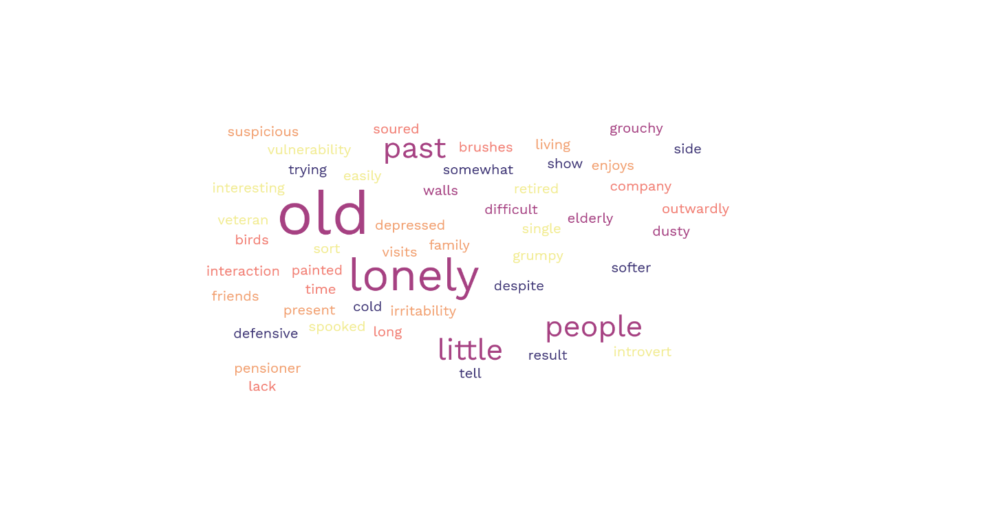

Figure : Word cloud generated from user responses to question 1

This question aimed to see if the character I had described in my Game Design Document could be effectively communicated to players from dialogue alone.

Even without any visuals, every participant identified that the character was old. Some other key characteristics defined in the GDD were also singled out, including their loneliness, keeping to themselves, and the concept that their irritability is mainly for show due to an awkwardness.

This is a really positive response and suggests that my writing style effectively communicates strong characterisation, rather than feeling flat, or vague.

*Q2: What problems would you guess the character might have in their life?*

* Loss
* Maybe relationship problems with family or others- not having good connections, and maybe not being accepted by people. Like having trouble making friends
* Loneliness, failed ambition, loss.
* Other people, they like their own company
* Primarily loneliness. If she does have any family they certainly don't visit often. On the rare occasion of human contact she reacts with hostility, likely because it's the path of least resistance for all the emotions she's had bottled up.
* Social anxitiy, lonelyness, issues with trust

This question aimed to see what the users would read into the character – no problems are explicitly stated, so it relies on successful subtle storytelling and building a character that users can empathise with and understand.

Every participant identified that the main problem the character faced was to do with other people – be it in the form of loss, loneliness, or social anxiety. This aligns with the character identified in the GDD, and supports the idea that users can read into their interactions to identify deeper issues.

*Q3: Which of these attributes would you say best describe the character? Select all that apply.*

This question aimed to get some quantitative data regarding the characterisation of the character.

Participants generally aligned on the keywords they chose to describe the character, showing that the writing delivers a clear, cohesive concept of the character that is universally understood by users.

*Section 2: STORYTELLING AND ACTIONS*

*Q4: After interacting with the character, how likely are you to try and help them in the game? (1 being* ***definitely wouldn’t****, 5 being* ***definitely would****)*

This question aimed to quantifiably check if players would, as intended, be inclined to help the character they met. Failure to strike the balance between a grumpy character that users still like enough to help would make the rest of gameplay feel forced and unnatural – if players don’t want to help the character but the only way to progress the game forward is to do so, they don’t feel as though they are the driving force of the game.

Thankfully, all respondents said they would try and help them in the game, showing that the storytelling successfully sets users up to follow flow of the story and be driven to complete the expected player actions.

*Q5: Do you think the player (you) could help the character? If so, how?*

* Get paint supplies
* I think the player could help them come out of their shell, by showing them care and respect as they did in the dialogue, and over time could help the person to trust people and feel less alone, especially as the characters are neighbours I think this gives them the time to slowly get there
* Try and engage further regarding the painting and see if it is a root cause for their anxiety.
* Give them painting supplies, install a bird bath outside their window, plant flowers for the insects to attract more birds
* Sneakily upgrade or refill their bird feeder. Anonymously deliver them new art supplies. Write to them instead of meeting in person, at least at first.
* Yes, by being a listening ear to hear about their love of nature and then past that creating areas in which you two can spend time with little talking. Doing different things alone.

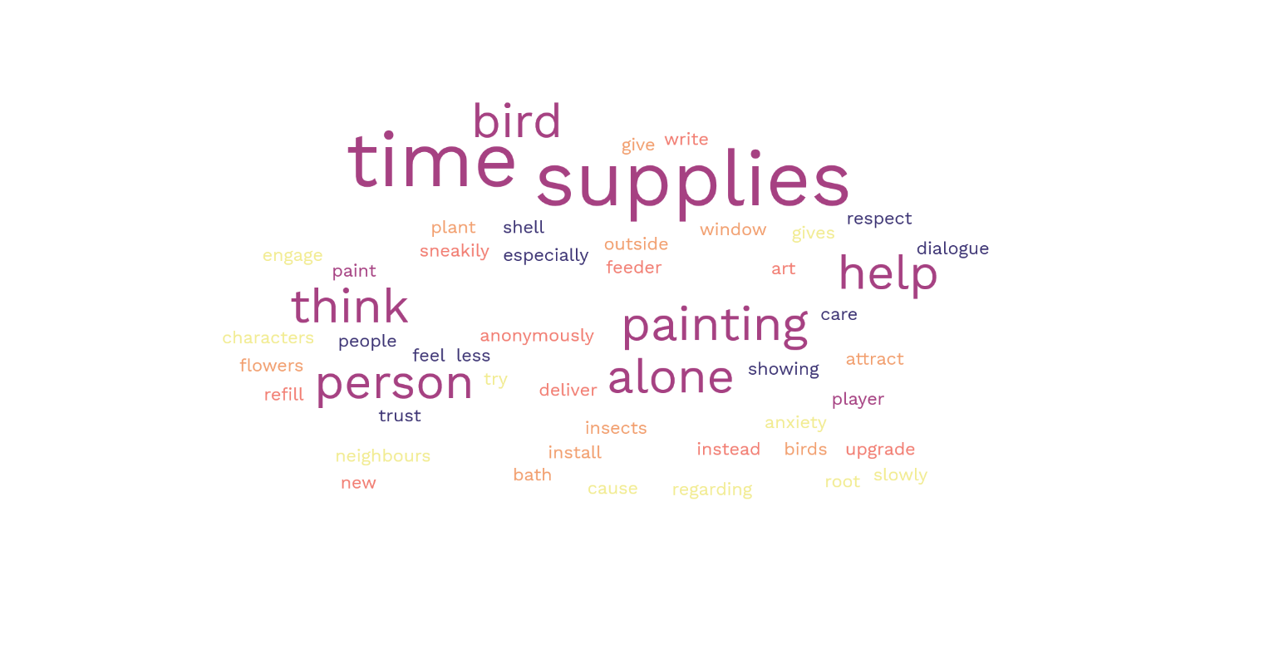

Figure : Word cloud generated from user responses to question 5

This question aimed to see what actions the players would be inclined to take in the game itself. Ideally, these would align with the solution identified in the GDD – bringing them art supplies, helping th

em build their interaction with nature and birds, and spending time with them.

As shown in the word cloud, the key themes of time, bird, supplies, and painting all came up a lot amongst responses. This is a positive result that supports the use of storytelling to subtly suggest solutions to problems.

In addition to describing the same type of help I had planned, respondents also identified some other ways the player could help which could be implemented in the game. Some of these ideas which I might reference in the dialogue and game design are:

* Installing a bird bath and planting flowers to attract more wildlife for them to enjoy
* Upgrading/refilling their bird feeder
* Helping them anonymously and writing to them to help ease their anxiety at face to face interactions
* Spending time together in a less-talky way – parallel play

*Q6: Do you think the character could help the player (you)? If so, how?*

* Teaching about birds and stuff
* Yes possibly as they could have things to share that they have never gotten to share with others before like practical skills but also I feel they would have potential to be a good and loyal friend if they became more comfortable and you built a relationship of some kind
* Not sure at this time - I'm more interested in their story
* Introduce them to their favourite spots in town, tell them about local events that new people might not get told about - like a guerilla gardening meetup or flower show
* I don't know enough about the player character to answer this.
* I think they are much wiser than I. They would know much more about the area especially in regard to nature and what the area needs from people

This question intended to look at how users would feel about an element I hadn’t explicitly planned. In designing these characters and their interactions, I only looked at how the player can help the character, so I wanted to see if the charactisation alone would drive users to come to similar conclusions.

As expected, some users didn’t know how to answer this question because they didn’t have enough information to guess.

The users who did have ideas all said the player could learn from the character – be it local information, events, nature knowledge, or practical skills. The fact that everyone aligned in identifying the character as an older, knowledgeable person who could teach the player character suggests that the characterisation is strong – everyone had the same understanding and thought process, rather than everyone pulling random ideas from thin air.

*Section 3: TONE AND STYLE*

*Q7: How would you describe the writing style? Consider the tone, anything it reminded you of.*

* Easy to read. Flows well
* Personal, detailed, immersive
* The writing certainly left me wanting to find out more - intriguing.
* Casual, short sentences, felt like natural dialogue
* Like an old GBA game.
* The writing style is jovial and lightherted on the surface but has a solum and awakrd undertone that bring the speed down to match the awkwardness

This question aimed to get a general understanding of how users felt about the style. The style is inspired by games such as *A Short Hike* and *Overboard!*, so any particular references to it being interesting, fun, light-hearted are especially positive.

All of the feedback was positive, and matches the general feel I was going for. I’ll continue to write the rest of the dialogue in a similar style, and create a quick reference sheet of key words and vibes to refer back to during writing so the style remains consistent throughout.

*Q8: Did you enjoy the writing style in this dialogue demo?*

This question aimed to get a general idea of how much the users enjoyed the writing style – just because they described it as expected in my previous questions that doesn’t mean they necessarily enjoyed reading it.   
  
Overall the response to the style was positive – most people didn’t say it was perfect though, so I’ll be sure to take note of improvements I can make from the upcoming sections to make my writing the best it can be.

*Q9: What did you like and dislike about the writing?*

* I though that some of the options seemed out of touch from previous responses. It felt like through certain tracks the character was warming to me but then snapped in a slightly disingenuous way
* It was engaging and made me keen to go further
* Good pace. Nice options. I went back and did it again to get different outcome
* It was hard to tell who was speaking sometimes - this might be improved by visuals or colour coding though. For the most part it was okay but I couldn't tell who was screaming when I peaked through the window.
* I really liked how easy it became to imagine how it would feel to have the conversation with this person, with the descriptions of tiny nuances in the other person, as well as the way you portrayed the slight discomfort and uncertainty of not knowing how to respond to certain things they said

The aim of this question was to get some detailed feedback on the writing style, and hopefully some suggestions as to how to improve it because I felt like I lacked a bit of direction when creating the demo.

This section provided me with the most constructive criticism I can use to improve the writing.

Someone pointed out that the dialogue seemed out of touch with previous responses, and the characters mood would change unexpectedly. This is because I created branching narrative options, but didn’t have previous interactions affect tone of future ones – I’ll work on having the tone vary based on previous interaction to make it feel more natural and less disjointed.